Product category: AC DRIVES (VFD’s)

AC DRIVE COMPANY

YASKAWA

1. Model name: YASKAWA A1000 SERIES

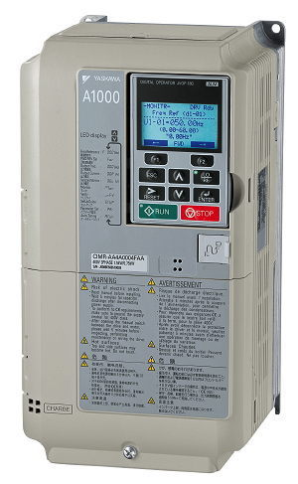

1. **MODEL NAME : YASKAWA V1000 SERIES**

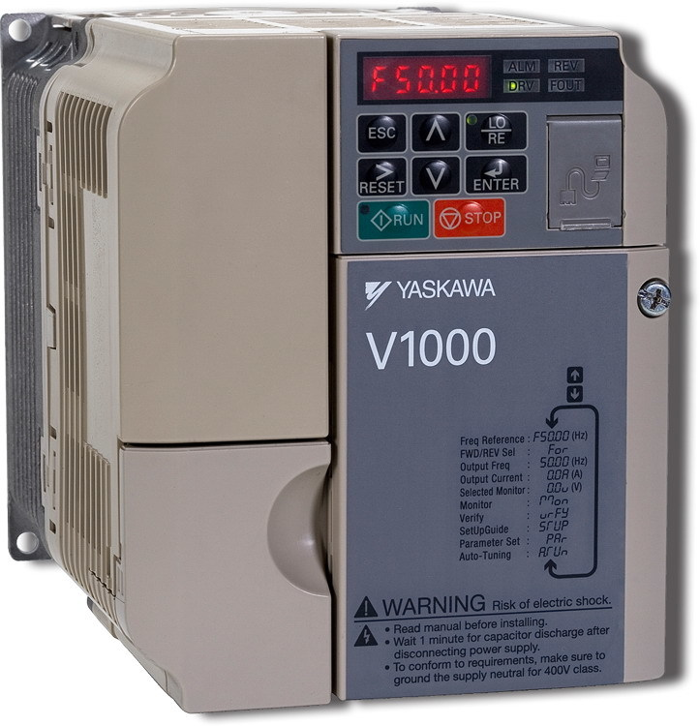

1. MODEL NAME: YASKAWA J1000 SERIES

[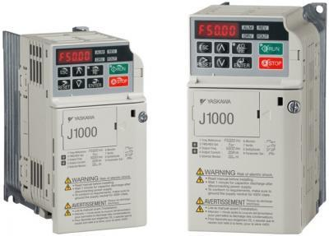](https://www.deltaelectronicsindia.com/industrial-automation/touch-panel-hmi-human-machine-interfaces/dop-w105b/" \o "DOP-W105B)

[MODEL NAME: YASKAWA GA 700 SERIES](https://www.deltaelectronicsindia.com/industrial-automation/touch-panel-hmi-human-machine-interfaces/dop-w105b/" \o "DOP-W105B)

[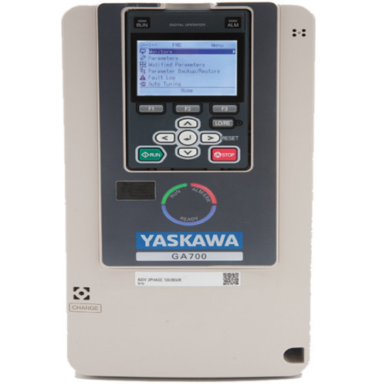](https://www.deltaelectronicsindia.com/industrial-automation/touch-panel-hmi-human-machine-interfaces/dop-w105b/" \o "DOP-W105B)

MODEL NAME: ALL OTHER YASKAWA DRIVES

[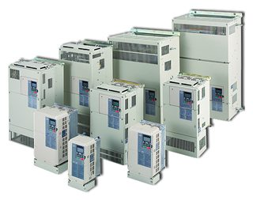](https://www.deltaelectronicsindia.com/industrial-automation/touch-panel-hmi-human-machine-interfaces/tp70p/" \o "TP70P)